**Livrabil intermediar**

Product Vision

1. RPGchess aims to bring a new chess variant for those who want a new twist to the regular chess game in an easily accessible, multiplayer platform.
2. Our game is developed for the chess players that play actively online. We are trying to offer an exciting alternative to the chess game
3. Our improved version of Chess will disrupt the monotony of the basic chess game. Our users will experience the joy of adapting to a new and more immersive and personal game environment, in which their on-board feats will accumulate experience, and will grant them new abilities by implementing a truly RPG-esque leveling system.
4. Success could be measured in multiple ways - while in initial development, it could be measured by how satisfied game testers are and, when released to the public, by the amount of active users and their engagement with the developers when it comes to balancing issues, recommendations, etc.
5. The core concept of the game is that the chess pieces will evolve during the game. After gathering enough xp, each chess piece can unlock different abilities, thus opening many possible strategies.
6. What separates us from the other chess variants is the narrative and evolutive nature of our version. While other variants have extra rules and features that apply from the start of the game, our additions depend on player choice, leading to ever-changing strategies.
7. The users would ideally remember RPGchess for its unique twist to the base game of chess. While regular chess can be controlled and slow, RPGchess can quickly spiral into chaos in just a few moves.
8. In an ideal scenario, the first version will be realese in February. We want to finish the gameplay logic in late December and to finish the frontend part in January.
9. In the early releases we will provide only PC browser support, with perspectives of also supporting Android and iOS versions in the future.

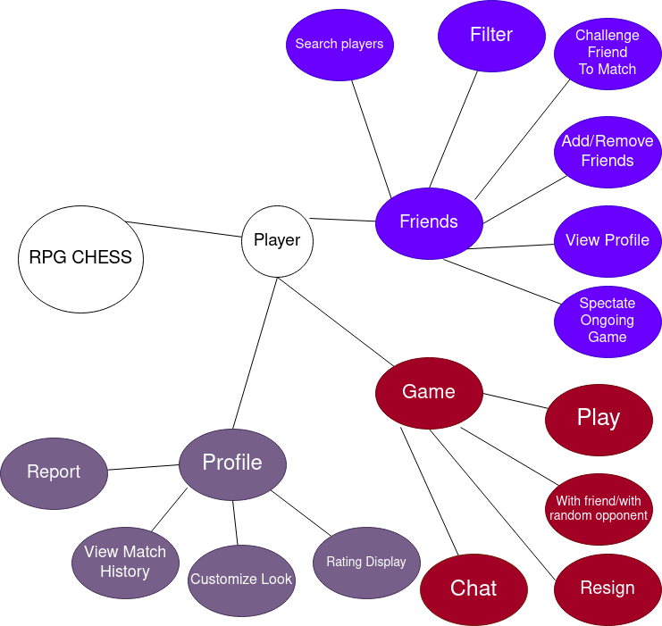

Features and Functionalities

Non-Functional Requirements

Availability:

* Users can play the game at any time throughout a usual day, except for a period of announced maintenance periods of no more than 3 hours and no more frequent than twice a month

Performance:

* For at least 1000 matches in progress, the delay time for each move (latency between user input and move execution on the server) should be smaller than 0.1 seconds.
* 99.9% of games should not contain bugs related to game continuity (i. e. that can interrupt the match or affect the outcome of the match)

Security:

* User activity should be conditioned by an account protected by username and password. Password length should be of at least 10 characters, must include at least 1 numeric character, 1 special character, 1 lowercase character and 1 uppercase character

Compatibility:

* The browser version of the app should be able to run on the following browsers following the first public release: Google Chrome, Opera, Firefox Mozilla and Safari

Ethical:

* Communication between users in the game should be respectful, so they must not contain the most used 20 forms of profanity in the English language (a language filter will be implemented)

User Persona:

Daniel Smith:

**Description:** Daniel is an ambitious student. He is very competitive and enjoys a good challenge. He loves strategic games and regularly watches Hikaru streams.

**Personality:** Introvert, Ambitious, Intellectual

**Goals:** He wants to have a great elo

**Problems:** He hates all the memorization in openings that comes with the regular chess game

Aurora Greenish

**Description:** Aurora is a 34 year old computer engineer. She started playing chess when she was in primary school, at the initiative of her father who signed her up to a chess class, in hopes that the game would improve her cognitive capacity. She fell in love with the game and participated every year in chess classes at her school until she finished highschool. She has played chess every day with the chess hustlers in the park near her house ever since.

**Personality:** Outgoing, laid-back, occasionally methodical and analytical

**Goals:** To continue to have fun playing her favorite game

**Problems:** Although she loves chess, it has started to feel somewhat repetitive and has lost its thrill to some extent. While playing chess, she seeks to recreate the euphoria she felt when she started playing in primary school.

‘

User Journey Map

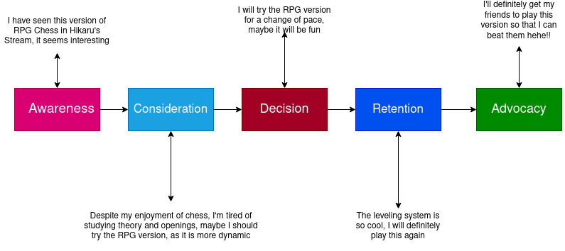

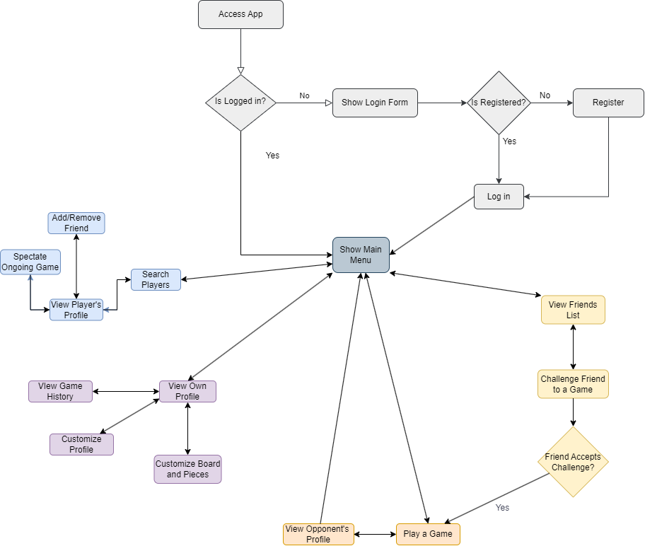

State diagram

User Stories

1. As a regular chess player, I want a more diverse variant of the game so there are fewer draws and more strategies.
2. As a regular chess player, I want to be able to choose my own starting pieces so I can use a playstyle that suits me.
3. As a competitive player, I want to log in so I can keep track of my ELO.
4. As a competitive player, I want to see the top leaderboard so I know who I should learn from.
5. As a player, I want a friends list so I can challenge my friends to a game.
6. As a competitive player, I want to see my game history so I can review my past mistakes.
7. As a player, I want to customize my profile so others can see information about my playstyle.
8. As a casual player, I want the game to be web based, so it is easier to access and play.
9. As a casual player, I want to be able to play unranked games, so there is less stress of losing ELO.
10. As a competitive player, I want to be able to play with the computer so I can learn new strategies.

Backlog:

Name Priority

create barebone server 100

create frontend display for basic chess game 100

implement frontend piece move actions (click, drag, etc.) 100

implement basic chess game logic 100

implement real time move update 100

implement logic for levelup abilities 90

add piece levelup system 90

create matchmaking system 80

create variable size chessboard game variant 60

create game variant with custom beginning setups 40

create barebone database 40

add authentication 35

store player details in database 35

store finished games in database 25

add ingame clock 30

add ingame chat 20

add board/pieces customisation 20

create ELO rating system 20

implement challenging friends to games 20

add game history 20

add leaderboards 15

add friends list 15

add player profile description 10

add chess engine 10